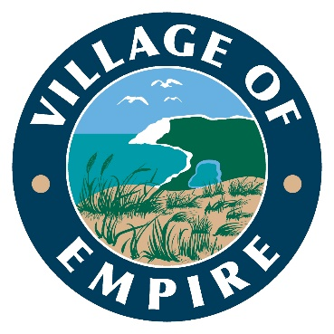

WATER COMMITTEE
MEETING NOTICE

Tuesday, May 14, 2024, 10:00 AM
Village Building
11518 S. Lacore Road, Empire, MI 49630

AGENDA:
Meeting with Representative from
Michigan Rural Water Association regarding Water Rate Study

Persons with questions or individuals with disabilities requiring auxiliary aids or services to effectively participate in the meeting should contact the Village of Empire Office at: (231) 326- 5466, PO Box 253, Empire, Ml 49630, or at deputyclerk@villageofempire.com.

